Triangle Angle Sum Theorem

Definition
# Source: AI Source: Provided by: [Data Path: Persons Table -> ID Column: 1, Name_En Column: Motasem Essam] -> From: [ChatGPT] on [7/25/2026]
The Triangle Angle Sum Theorem states that the sum of the three interior angles of any triangle is always equal to:
$$\boxed{{180}^{∘}}$$
For a triangle $ABC$:
$$\boxed{m∠A+m∠B+m∠C={180}^{∘}}$$
This property is true for every triangle, regardless of its side lengths or shape.
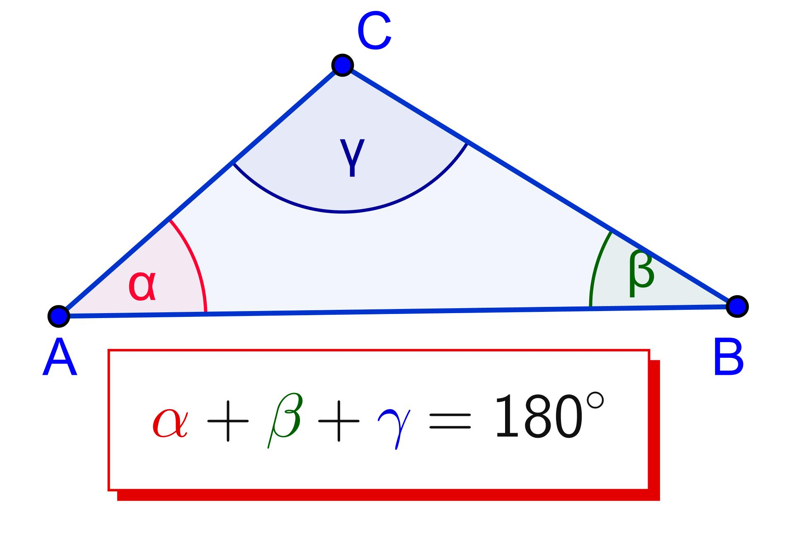
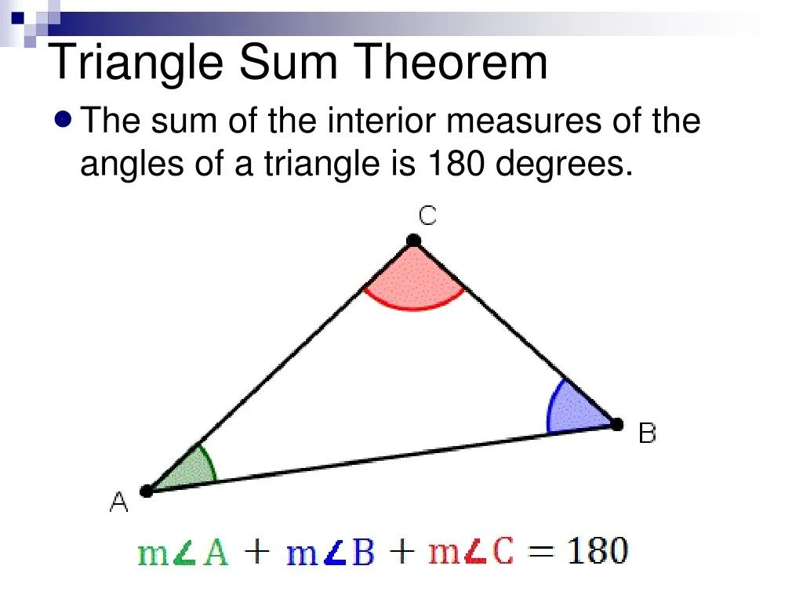
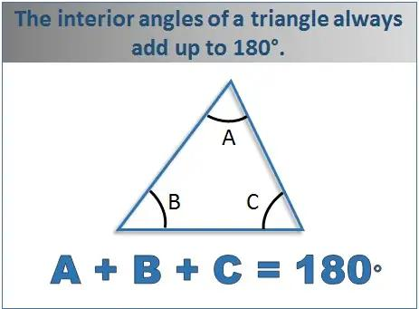
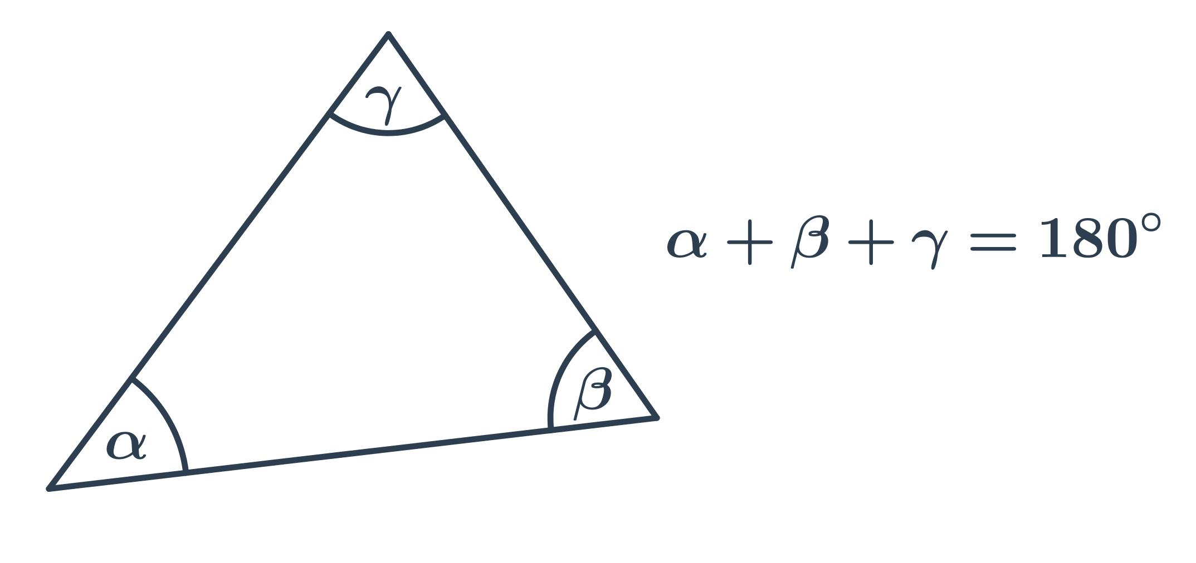
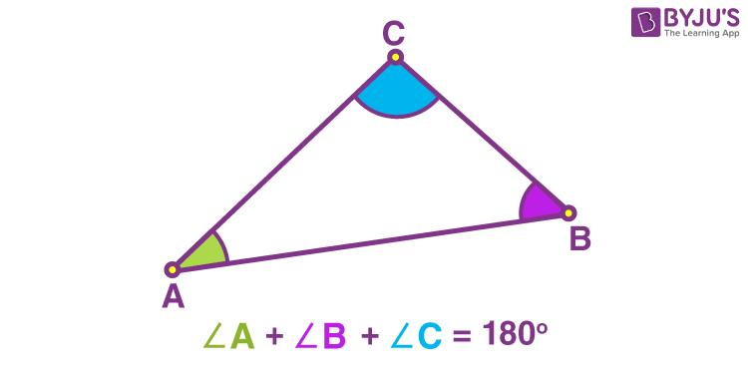

Purpose
# Source: AI Source: Provided by: [Data Path: Persons Table -> ID Column: 1, Name_En Column: Motasem Essam] -> From: [ChatGPT] on [7/25/2026]
The Triangle Angle Sum Theorem is used to:
- Find an unknown angle in a triangle.
- Verify angle measurements.
- Classify triangles by their angles.
- Solve geometric problems.
- Establish relationships between angles.
- Support geometric proofs.
- Analyze polygons and other geometric figures.

Interior Angles of a Triangle
# Source: AI Source: Provided by: [Data Path: Persons Table -> ID Column: 1, Name_En Column: Motasem Essam] -> From: [ChatGPT] on [7/25/2026]
Every triangle has exactly three interior angles.
For triangle $ABC$:
$$∠A, ∠B, ∠C$$
Their sum is always:
$$\boxed{{180}^{∘}}$$
Therefore:
$$\boxed{A+B+C={180}^{∘}}$$
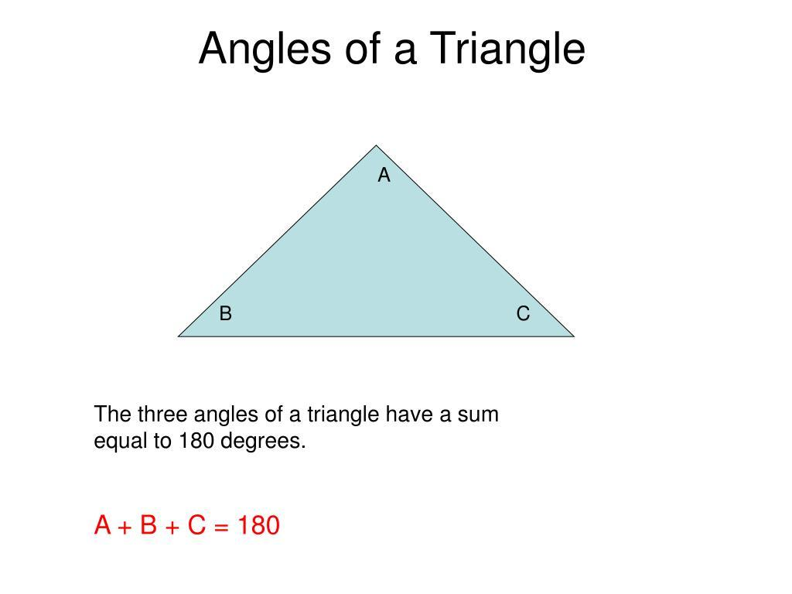
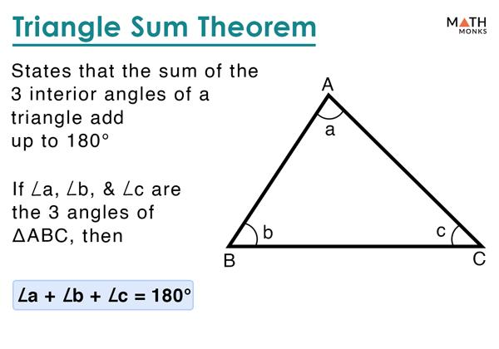
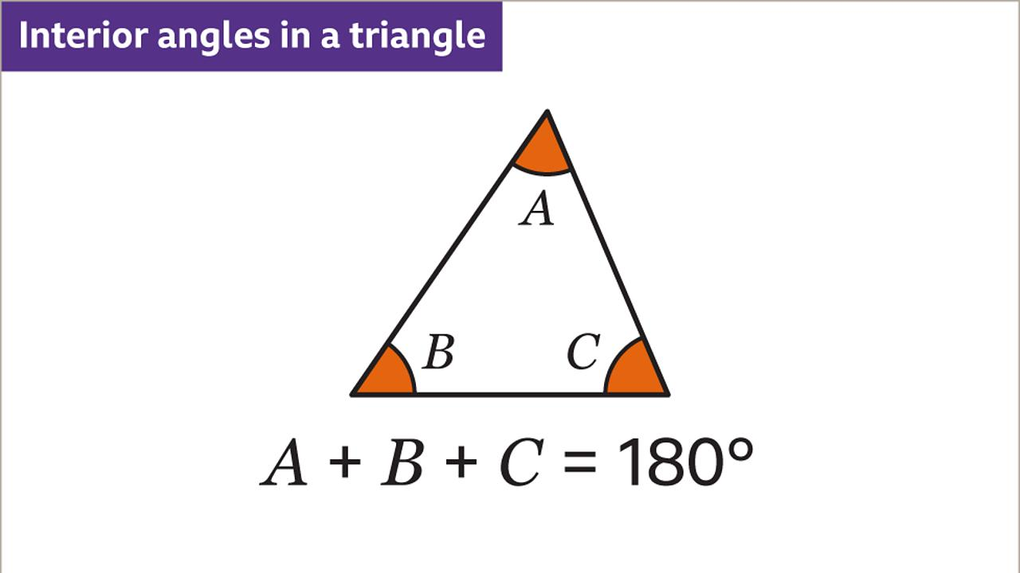
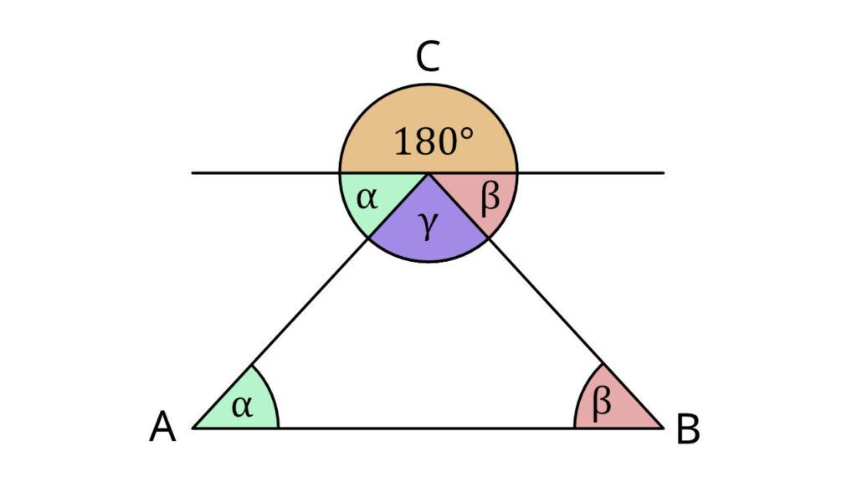

Mathematical Representation
# Source: AI Source: Provided by: [Data Path: Persons Table -> ID Column: 1, Name_En Column: Motasem Essam] -> From: [ChatGPT] on [7/25/2026]
For any triangle:
$$\boxed{m∠A+m∠B+m∠C={180}^{∘}}$$
If one angle is unknown:
$$\boxed{x={180}^{∘}-\left(A+B\right)}$$
where $x$is the unknown angle.

Example 1 — Finding an Unknown Angle
# Source: AI Source: Provided by: [Data Path: Persons Table -> ID Column: 1, Name_En Column: Motasem Essam] -> From: [ChatGPT] on [7/25/2026]
Suppose:
$$∠A={50}^{∘}$$
and:
$$∠B={60}^{∘}$$
Find $∠C$.
Using:
$$A+B+C={180}^{∘}$$
we get:
$${50}^{∘}+{60}^{∘}+C={180}^{∘} \\ {110}^{∘}+C={180}^{∘}$$
Therefore:
$$\boxed{C={70}^{∘}}$$

Example 2 — Right Triangle
# Source: AI Source: Provided by: [Data Path: Persons Table -> ID Column: 1, Name_En Column: Motasem Essam] -> From: [ChatGPT] on [7/25/2026]
Suppose a right triangle has:
$$∠A={90}^{∘}$$
and:
$$∠B={35}^{∘}$$
Then:
$${90}^{∘}+{35}^{∘}+C={180}^{∘}$$
Therefore:
$$C={180}^{∘}-{125}^{∘} \\ \boxed{C={55}^{∘}}$$
The two non-right angles of a right triangle always add to:
$$\boxed{{90}^{∘}}$$
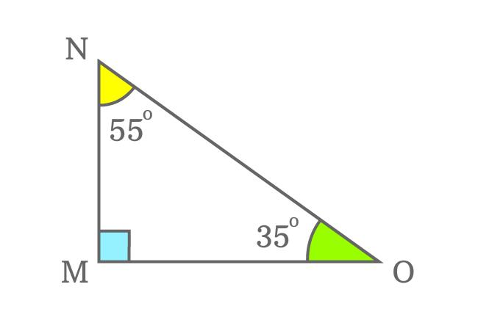
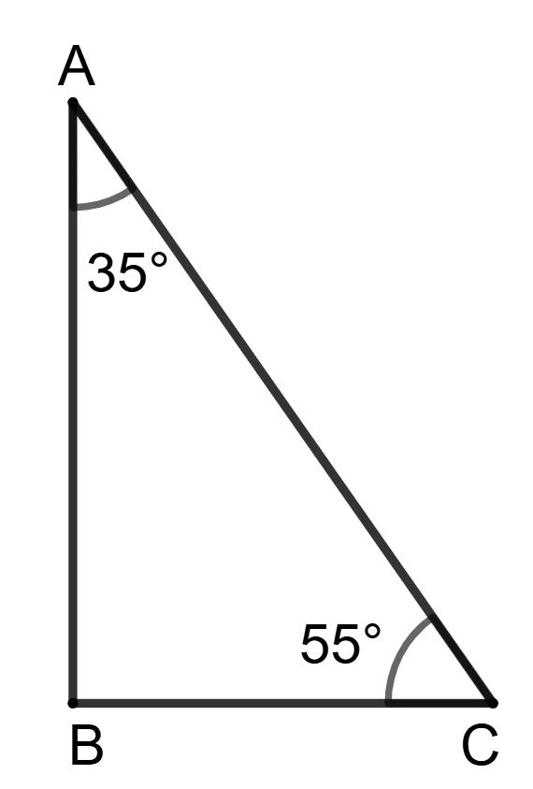
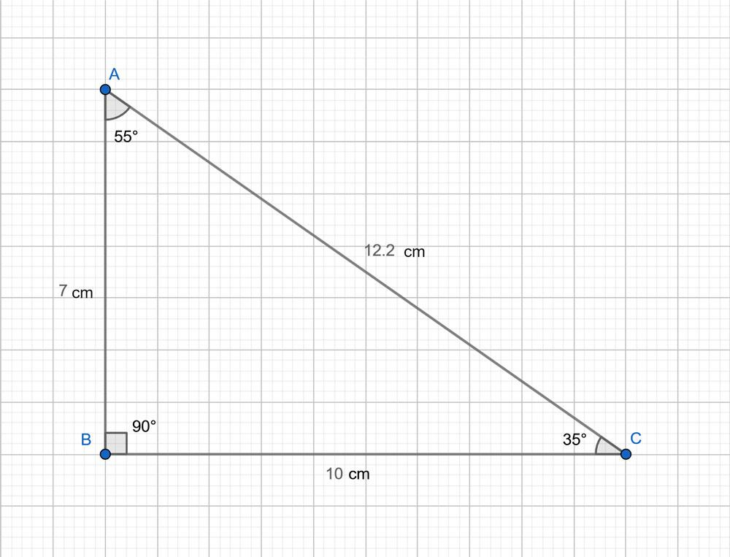
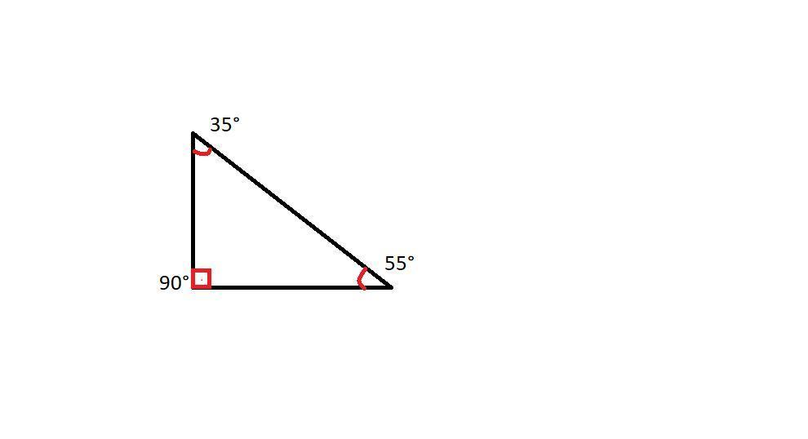

Example 3 — Equilateral Triangle
# Source: AI Source: Provided by: [Data Path: Persons Table -> ID Column: 1, Name_En Column: Motasem Essam] -> From: [ChatGPT] on [7/25/2026]
An equilateral triangle has three equal angles.
Let each angle be $x$:
$$x+x+x={180}^{∘} \\ 3x={180}^{∘}$$
Therefore:
$$\boxed{x={60}^{∘}}$$
Thus, every angle in an equilateral triangle measures:
$$\boxed{{60}^{∘}}$$

Example 4 — Isosceles Triangle
# Source: AI Source: Provided by: [Data Path: Persons Table -> ID Column: 1, Name_En Column: Motasem Essam] -> From: [ChatGPT] on [7/25/2026]
Suppose an isosceles triangle has two equal base angles:
$${50}^{∘}, {50}^{∘}$$
Let the third angle be $x$.
$${50}^{∘}+{50}^{∘}+x={180}^{∘} \\ {100}^{∘}+x={180}^{∘}$$
Therefore:
$$\boxed{x={80}^{∘}}$$

Relationship with Triangle Classification
# Source: AI Source: Provided by: [Data Path: Persons Table -> ID Column: 1, Name_En Column: Motasem Essam] -> From: [ChatGPT] on [7/25/2026]
The Triangle Angle Sum Theorem helps classify triangles.
Acute Triangle
All three angles are less than:
$${90}^{∘}$$
Right Triangle
One angle is exactly:
$${90}^{∘}$$
Obtuse Triangle
One angle is greater than:
$${90}^{∘}$$
Since the total is always ${180}^{∘}$, a triangle cannot have two right or two obtuse angles.
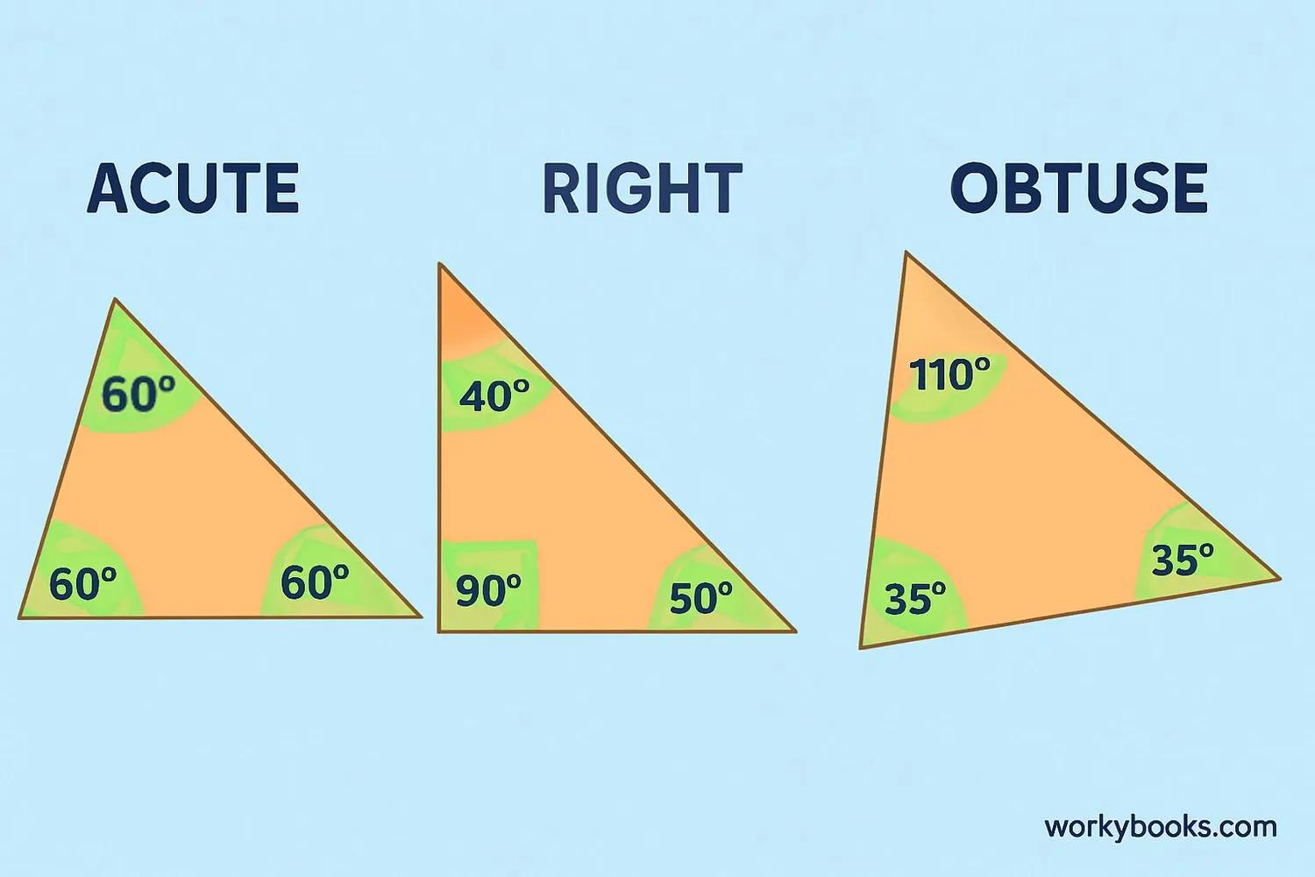
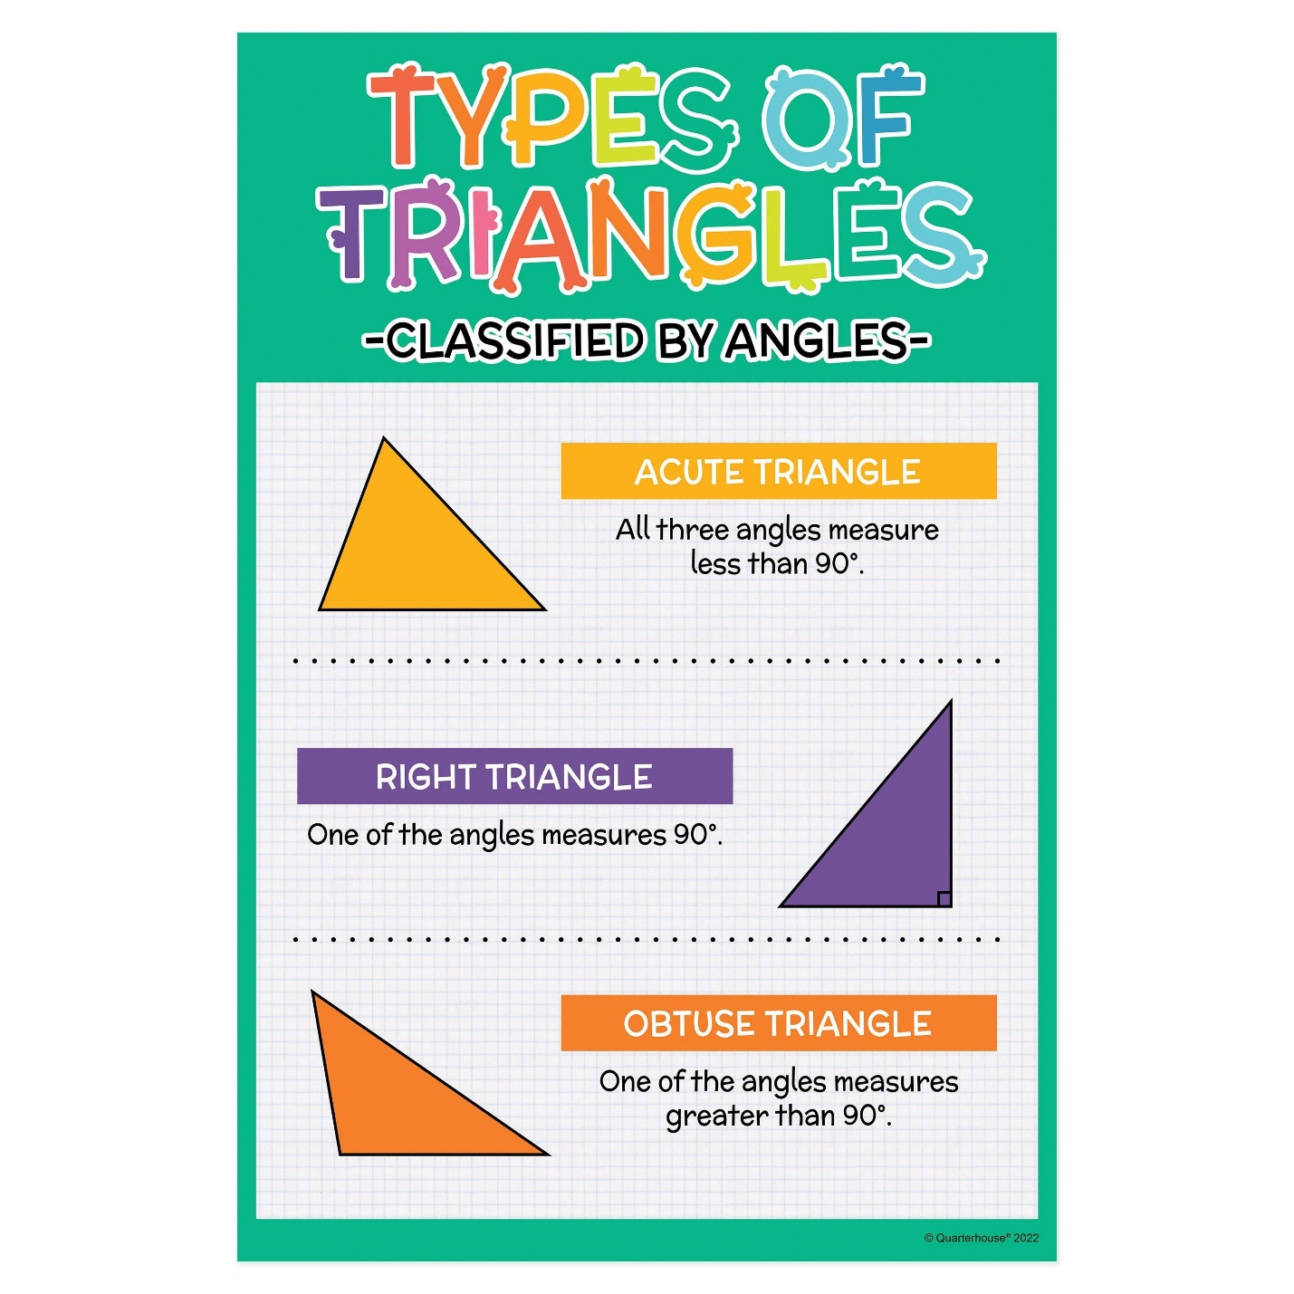
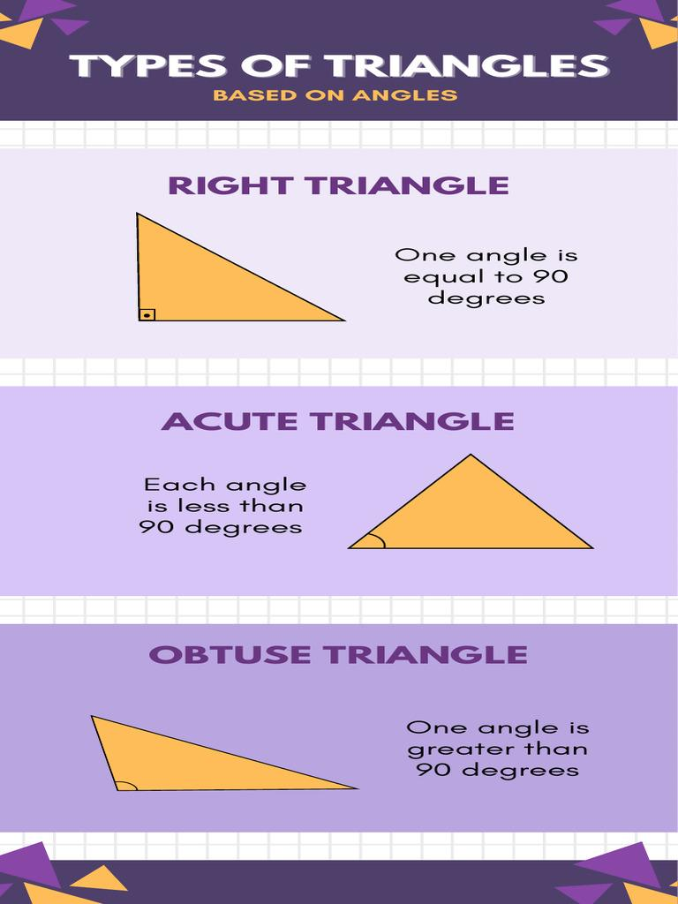

Proof of the Triangle Angle Sum Theorem
# Source: AI Source: Provided by: [Data Path: Persons Table -> ID Column: 1, Name_En Column: Motasem Essam] -> From: [ChatGPT] on [7/25/2026]
One common proof uses a line parallel to one side of the triangle.
Consider triangle $ABC$. Draw a line through $A$ parallel to $BC$.
Because the lines are parallel, alternate interior angles are equal.
The three angles along the straight line at $A$ form:
$${180}^{∘}$$
Therefore:
$$∠A+∠B+∠C={180}^{∘}$$
Hence:
$$\boxed{m∠A+m∠B+m∠C={180}^{∘}}$$
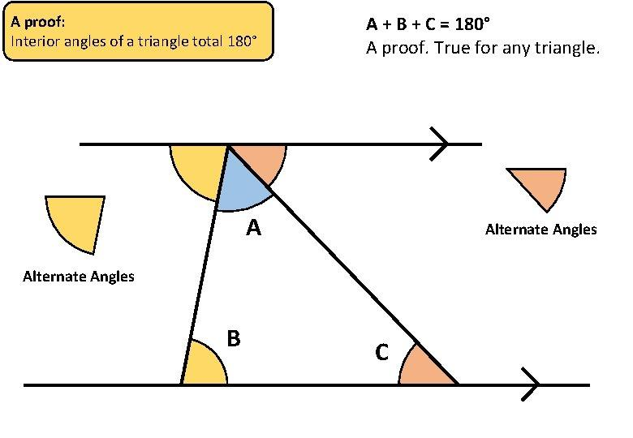
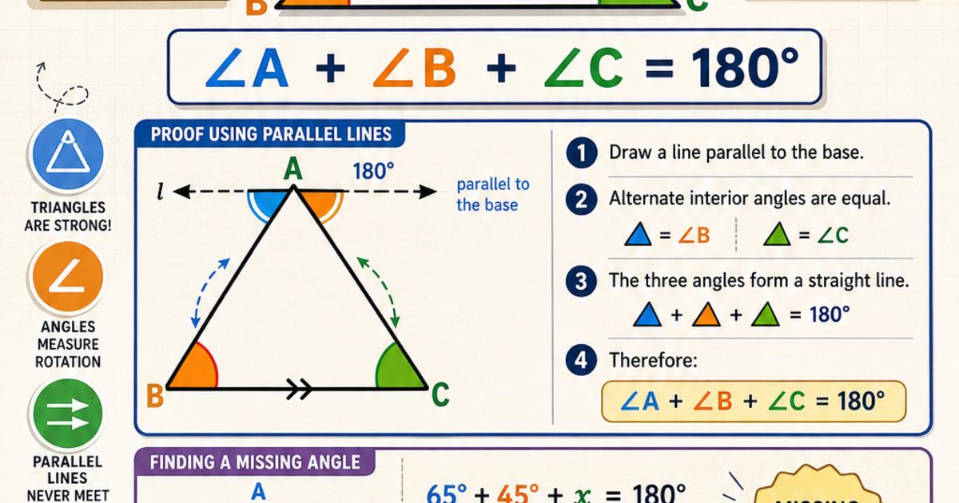
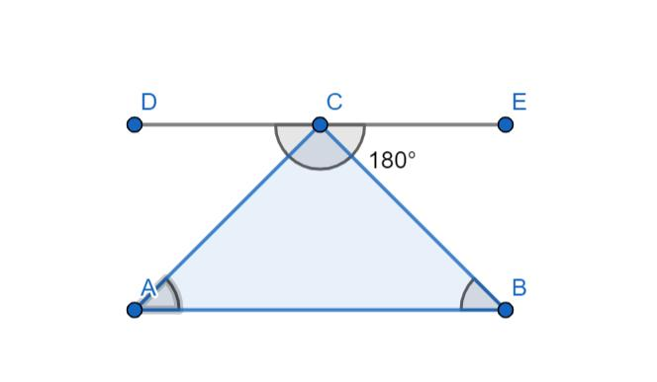

Relationship with the Exterior Angle Theorem
# Source: AI Source: Provided by: [Data Path: Persons Table -> ID Column: 1, Name_En Column: Motasem Essam] -> From: [ChatGPT] on [7/25/2026]
The Triangle Angle Sum Theorem is directly related to the Exterior Angle Theorem.
If:
$$A+B+C={180}^{∘}$$
and an exterior angle $E$ forms a straight angle with $C$:
$$E+C={180}^{∘}$$
then:
$$E=A+B$$
Therefore:
$$\boxed{\text{Exterior Angle}=\text{sum of two remote interior angles}}$$
So the Exterior Angle Theorem can be derived from the Triangle Angle Sum Theorem.

Special Cases

Equilateral Triangle
# Source: AI Source: Provided by: [Data Path: Persons Table -> ID Column: 1, Name_En Column: Motasem Essam] -> From: [ChatGPT] on [7/25/2026]
$${60}^{∘}+{60}^{∘}+{60}^{∘}={180}^{∘}$$

Isosceles Triangle
# Source: AI Source: Provided by: [Data Path: Persons Table -> ID Column: 1, Name_En Column: Motasem Essam] -> From: [ChatGPT] on [7/25/2026]
If the equal angles are $A$ and $B$:
$$A=B$$
then:
$$2A+C={180}^{∘}$$

Right Triangle
# Source: AI Source: Provided by: [Data Path: Persons Table -> ID Column: 1, Name_En Column: Motasem Essam] -> From: [ChatGPT] on [7/25/2026]
If:
$$C={90}^{∘}$$
then:
$$A+B={90}^{∘}$$

Relationship Between Sides and Angles
# Source: AI Source: Provided by: [Data Path: Persons Table -> ID Column: 1, Name_En Column: Motasem Essam] -> From: [ChatGPT] on [7/25/2026]
The theorem works together with the relationship between side lengths and opposite angles.
The:
$$\boxed{\text{largest side}}$$
is opposite the:
$$\boxed{\text{largest angle}}$$
and the:
$$\boxed{\text{smallest side}}$$
is opposite the:
$$\boxed{\text{smallest angle}}$$
This relationship helps analyze and classify triangles.

Applications
# Source: AI Source: Provided by: [Data Path: Persons Table -> ID Column: 1, Name_En Column: Motasem Essam] -> From: [ChatGPT] on [7/25/2026]
The Triangle Angle Sum Theorem is important in:
- Plane Geometry
- Triangle Geometry
- Euclidean Geometry
- Trigonometry
- Coordinate Geometry
- Architecture
- Engineering
- Surveying
- CAD
- Computer Graphics
- Navigation
- Construction
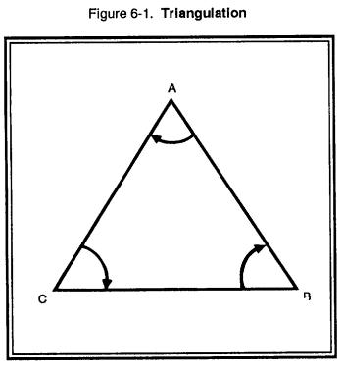
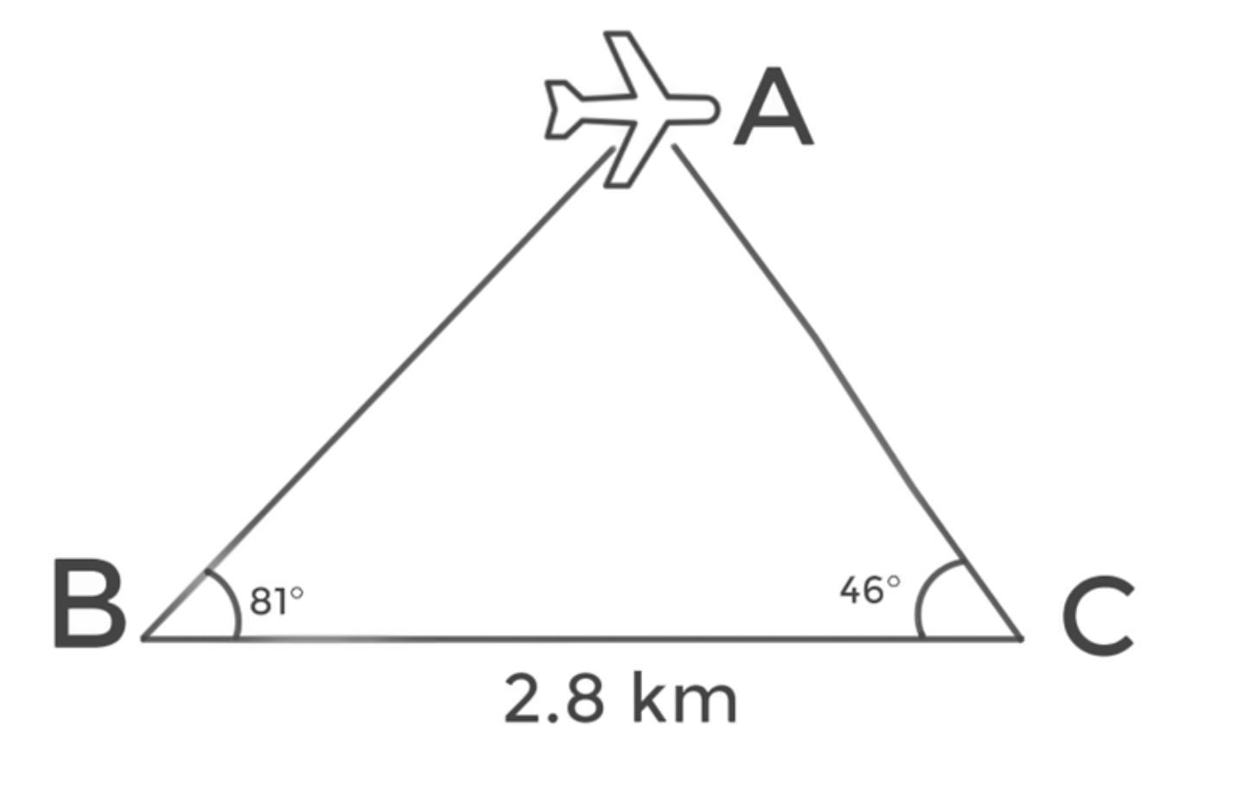
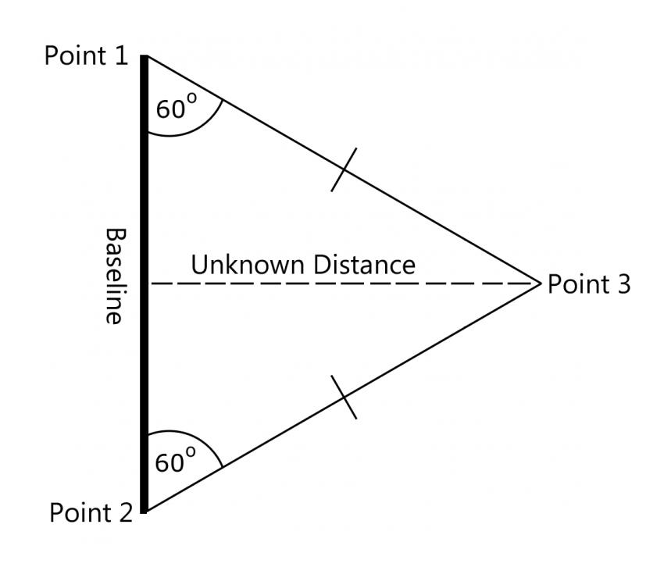

Real-World Examples
# Source: AI Source: Provided by: [Data Path: Persons Table -> ID Column: 1, Name_En Column: Motasem Essam] -> From: [ChatGPT] on [7/25/2026]
Triangle angle relationships appear in:
- Roof structures.
- Bridge supports.
- Building frames.
- Land surveying.
- Navigation.
- Structural engineering.
- Computer graphics.
- Technical drawings.
For example, surveyors can use known angles to calculate unknown angles and determine geometric relationships between measured points.

Advantages
# Source: AI Source: Provided by: [Data Path: Persons Table -> ID Column: 1, Name_En Column: Motasem Essam] -> From: [ChatGPT] on [7/25/2026]
The Triangle Angle Sum Theorem helps to:
- Find unknown angles quickly.
- Verify geometric calculations.
- Classify triangles.
- Solve triangle problems.
- Support geometric proofs.
- Establish the Exterior Angle Theorem.
- Analyze more complex geometric figures.

Limitations
# Source: AI Source: Provided by: [Data Path: Persons Table -> ID Column: 1, Name_En Column: Motasem Essam] -> From: [ChatGPT] on [7/25/2026]
The theorem:
- Applies directly to the three interior angles of a triangle.
- Does not directly determine side lengths.
- Requires the angles to be measured or represented correctly.
- The ${180}^{∘}$result applies to triangles in Euclidean plane geometry.

Comparison with Related Theorems
# Source: AI Source: Provided by: [Data Path: Persons Table -> ID Column: 1, Name_En Column: Motasem Essam] -> From: [ChatGPT] on [7/25/2026]
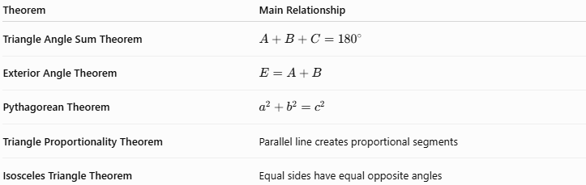
Theorem | Main Relationship
Triangle Angle Sum Theorem | $$A+B+C={180}^{∘}$$
Exterior Angle Theorem | $$E=A+B$$
Pythagorean Theorem | $$a^{2}+b^{2}=c^{2}$$
Triangle Proportionality Theorem | Parallel line creates proportional segments
Isosceles Triangle Theorem | Equal sides have equal opposite angles

Key Points
# Source: AI Source: Provided by: [Data Path: Persons Table -> ID Column: 1, Name_En Column: Motasem Essam] -> From: [ChatGPT] on [7/25/2026]
- Every triangle has three interior angles.
- The sum of the three interior angles is always:
$$\boxed{{180}^{∘}}$$
- The general formula is:
$$\boxed{A+B+C={180}^{∘}}$$
- An unknown angle can be found using:
$$\boxed{x={180}^{∘}-\left(A+B\right)}$$
- An equilateral triangle has three ${60}^{∘}$ angles.
- A right triangle has one ${90}^{∘}$ angle.
- An obtuse triangle has one angle greater than ${90}^{∘}$.
- Two angles of a right triangle always sum to ${90}^{∘}$.
- The theorem is fundamental to triangle geometry and many other geometric relationships.

Conclusion
# Source: AI Source: Provided by: [Data Path: Persons Table -> ID Column: 1, Name_En Column: Motasem Essam] -> From: [ChatGPT] on [7/25/2026]
The Triangle Angle Sum Theorem states that the three interior angles of every triangle have a total measure of:
$$\boxed{{180}^{∘}}$$
This fundamental theorem provides a simple and powerful method for finding unknown angles and understanding the structure of triangles. It is closely connected to triangle classification, the Exterior Angle Theorem, parallel lines, geometric proofs, trigonometry, surveying, engineering, and architecture.

